**Heroes of Pymoli Analysis**

**Notes :**

Of the 1163 active players, the vast majority are male (84%). There also exists, a smaller, but notable proportion of female players (14%).

Our peak age demographic falls between 20-24 (44.8%) with secondary groups falling between 15-19 (18.60%) and 25-29 (13.4%).

**Observations**

1. Purchase Analysis Gender Table : Based on the table below, the vast majority are males (652) and have the highest "Total Purchase Value" of $1967.64 , however , on average they only spent $ 0.19 more than “Female” gender. “Other/Non disclosed” group on average spent the most

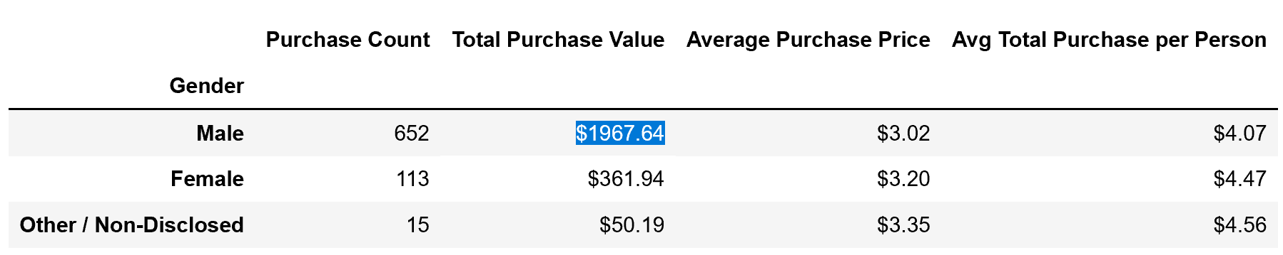

1. Age Demographics Table : Based on the table below , 63 % of the player base are in the combined age groups of 15-24 , with the 20-24 age range making up 44.8% of the player base

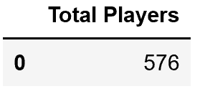

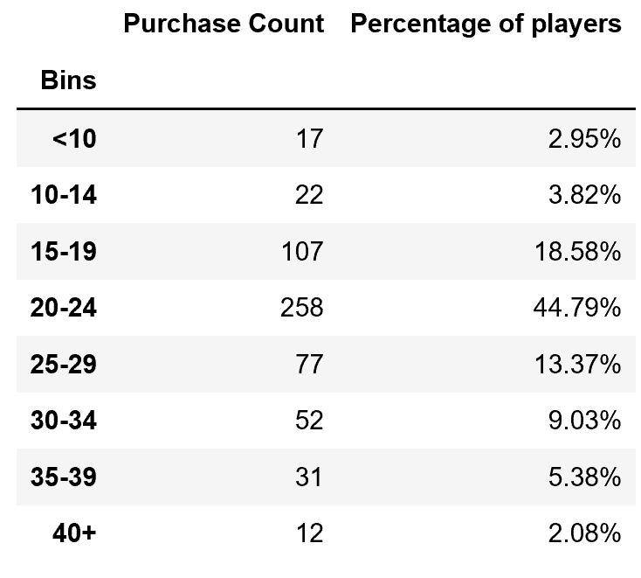

1. Most Popular Items Table : The most popular items are the most profitable items, leads to a conclusion that the more items sold yields more profit, although lower priced items do exist which did not yeild max profit.

